- Create database springDemo with user table with fields
(a) username
(b) password
(c) name
(d) age
(e) dob
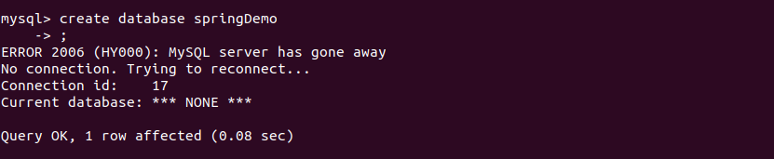
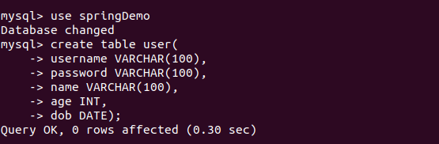
- Insert few records inside user Tables
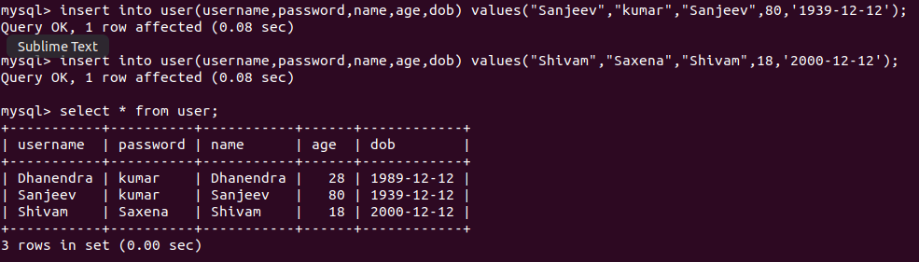
- Use datasource with DriverManagerDataSource, dbcp2.BasicDataSource and
- SingleConnectionDataSource to print the records of user tables
- Use JdbcTemplate to get the count of users
- Get name of the user by providing username to the parametrized query
- Insert one record using JdbcTemplate
- Use QueryForMap to fetch the user details of the user
- Use QueryForList to fetch records of all users
- Use a rowmapper to get the User object when you query for a user
- Integrate Hibernate with Spring and use hql query to count the number of records in user table.
- Use @Transactional to save to save 2 records using jdbc template with the following prapogation options
  - REQUIRED
  - REQUIRES_NEW
  - NESTED
  - MANDATORY
  - NEVER
  - NOT_SUPPORTED
  - SUPPORTS
- Demonstrate the use of following options of @Transactional annotation
  - read-only
  - timeout
  - rollback-for
  - no-rollback-for

